Ecosystems Pre and Post Test

1. | Temperature, light, air, water, soil, and climate are all __________ parts of the environment.

A. | biotic

B. | abiotic

C. | boreal

D. | living

2. | Choose the phrase that correctly finishes this statement: "A species is..."

A. | a specific part of the abiotic environment

B. | a way of describing all the living parts of an ecosystem

C. | a group of organisms that can successfully mate with each other and reproduce

D. | part of the natural decomposing materials in soil

3. | Ecology is the study of the

A. | abiotic parts of the environment, such as climate, air, and soil

B. | biotic parts of the environment, such as animals and plants

C. | interactions between organisms

D. | interactions between organisms as well as the interactions between organisms and their environment

4. | What is an ecosystem?

A. | All the interacting organisms that live in an environment and the abiotic parts of the environment that affect the organisms

B. | A person who observes and studies the interactions between the biotic and abiotic parts of the environment

C. | The relationship among the biotic parts of the environment

D. | The relationship between all the abiotic elements of a pond

5. | When populations share their environment and interact with populations of other species, it is called a

A. | biome

B. | ecoprovince

C. | community

D. | species

6. | The space where an organism lives and the role an organism plays within its ecosystem is referred to as a

A. | sampling

B. | community

C. | population

D. | niche

7. | An organism that creates its own food is called

A. | a producer

B. | a consumer

C. | a scavenger

D. | a decomposer

8. | A consumer is

A. | an organism that produces its own food

B. | an organism that does not need food to survive

C. | an abiotic organism

D. | an organism that cannot produce its own food

9. | Which of the following two organisms are producers?

A. | plants and phytoplankton

B. | plants and consumers

C. | consumers and phytoplankton

D. | phytoplankton and chlorophyll

10. | A food web is more realistic than a food chain for showing the feeding relationships in ecosystems because

A. | it compares the number of consumers to the number of micro-organisms in an ecosystem

B. | food chains use only a small sampling of organisms.

C. | a food web explains why there are more producers than consumers.

D. | producers are usually eaten by many different consumers and most consumers are eaten by more than one predator

11. | The largest percentage of solar energy that penetrates the atmosphere of the Earth is used to

A. | heat the atmosphere and the Earth’s surface.

B. | carry on photosynthesis.

C. | generate winds.

D. | heat and evaporate water.

12. | A species of plant or animal that is facing imminent extinction or extirpation is said to be

A. | extinct

B. | extirpated

C. | endangered

D. | threatened

13. | Consider this food chain: algae --> water fleas --> minnows --> trout --> bear  The minnows in this food chain are…..

A. | top carnivores

B. | tertiary carnivores

C. | secondary carnivores

D. | primary carnivores

14. | Heterotrophs obtain energy from all of the following except:

A. | autotrophs

B. | herbivores

C. | solar radiation

D. | other heterotrophs

15. | For the food web below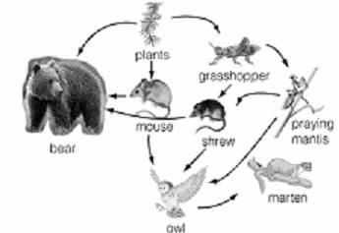  what does the praying mantis represent?

A. | a primary consumer

B. | a secondary consumer

C. | a tertiary consumer

D. | a producer

16. | How many primary consumers are there in the following food web?

A. | 1

B. | 2

C. | 3

D. | 4

.

17. | Which of the following is NOT an abiotic factor

A. | decomposer

B. | light intensity

C. | wind

D. | humidity

.

18. | The graph below shows the changes in the size of the populations of two different species of paramecia placed in one beaker.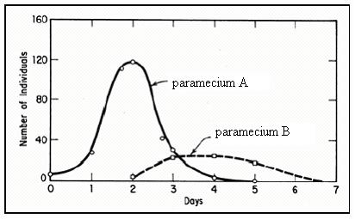  What can be concluded from this graph?

A. | Paramecium A is the predator, paramecium B is the prey

B. | Paramecium B is the predator, paramecium A is the prey

C. | The introduction of paramecium B is followed by a decline in the population of paramecium A

D. | Paramecium B reaches a steady state of growth

